Testable Code with Moq using NUnit
IMailSender.cs
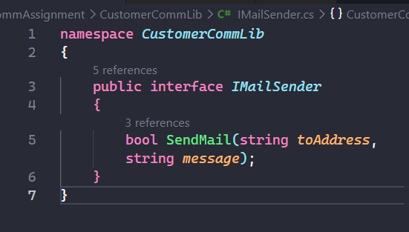
MailSender.cs
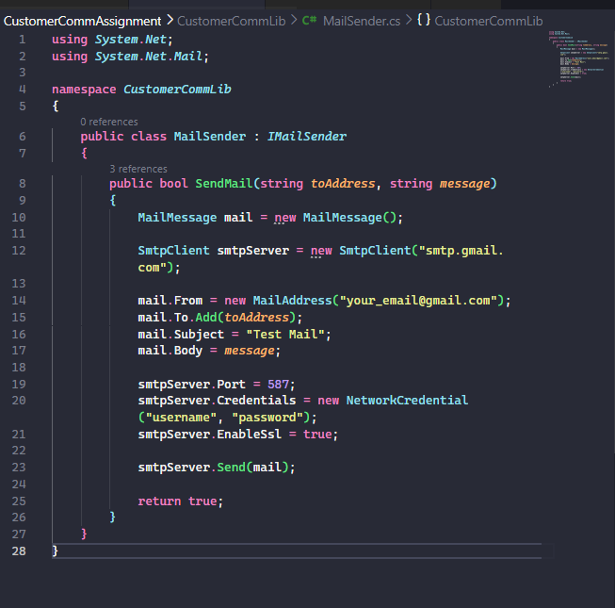

CustomerComm.cs
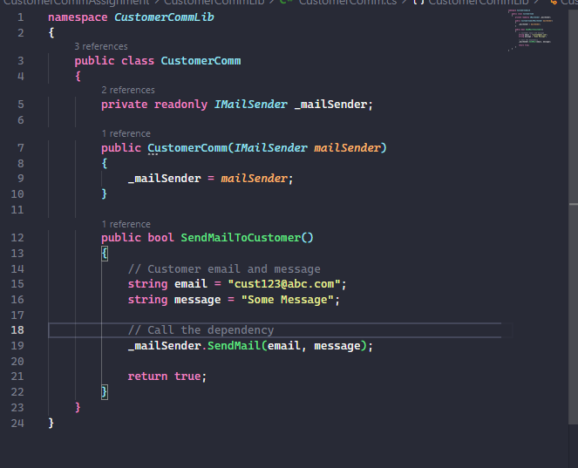
CustomerCommTests.cs
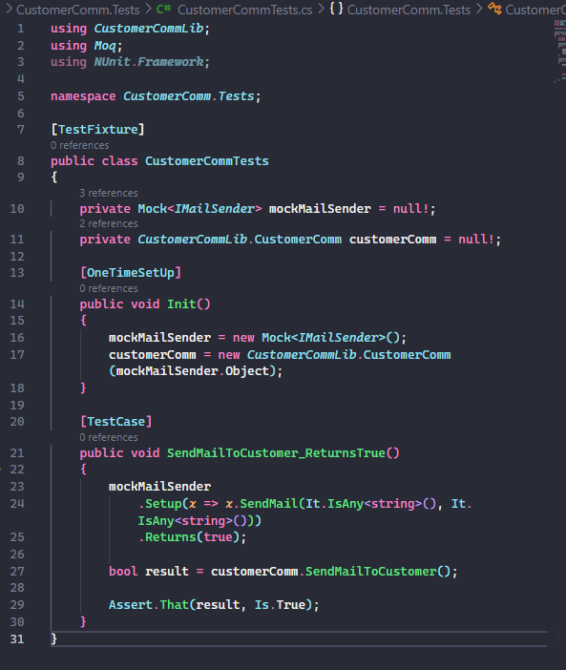
OUTPUT:
